Ministry Development Plan

Name: __________________________________________________ Date: _________________________

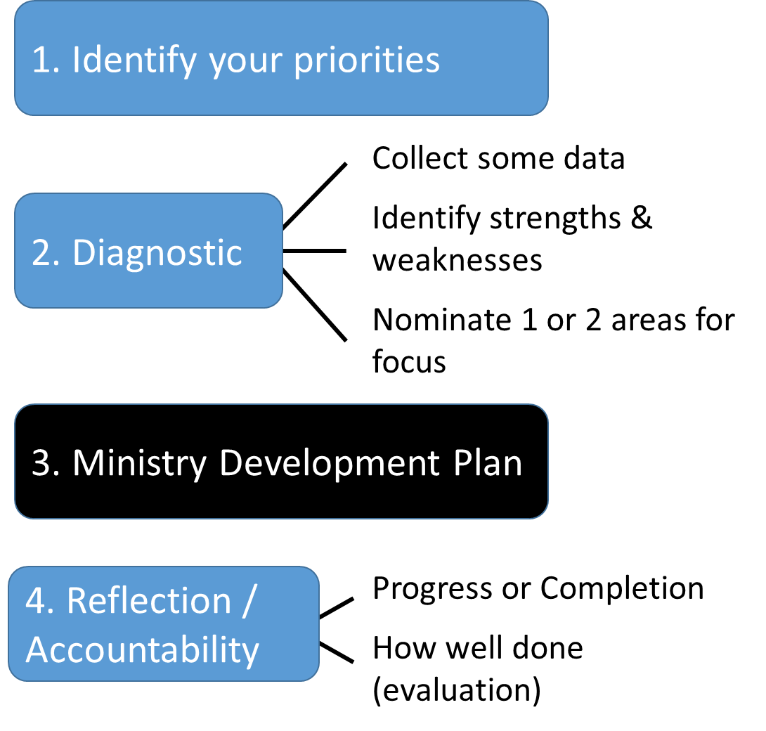
The purpose of the Ministry Development Plan is to provide you with some structure to deliberately and prayerfully consider how you might develop and grow in God’s service over the next months and years.

Identify your priorities:

- ____________________________________________________________
- ____________________________________________________________
- ____________________________________________________________

2. Diagnostic:
- How will / have you collected data? (see explanatory notes for ideas)
_____________________________________________________________
_____________________________________________________________
- Identify key Strengths & Weaknesses

Key strengths identified | Key areas you could improve

- Focus for Development (1 or 2 areas)
_______________________________________________________________
_______________________________________________________________
_______________________________________________________________

3. Ministry Development Plan

Development Focus  (incl. supporting data) | Activities proposed to address focus | Proposed dates | Expected Outcomes

Reflection / Accountability

Activities proposed to address focus | Progress / Completion | How well have I done? (evaluation)

- Date of reflection / accountability ________________________________________
- Name of person who you would like to help keep you accountable ______________________________________

Explanatory Notes
- 1. Identify your priorities: Consider the different areas associated with your role e.g. pastor, leader, preacher or missionary or consider some of the characteristics that relate to who you are as a person eg character, transformed nature, theology, faith system, gospel wisdom etc. Perhaps consider convictions, character and competencies for the roles of pastor, leader, preacher and missionary.
  - Think about the ministries you are focusing on – which competencies, skills, knowledge or behaviours are most important in that role? Is the role largely tactical, strategic or a bit of both? Is it largely one-on-one ministry, equipping others (staff or lay leaders), teaching large groups, or more behind the scenes?
It’s also worth thinking about where you might be in 2, 5 and 10 years’ time. Which arenas will you need to strengthen or continue to grow in?
  - If you need help in identifying priorities a more macro analysis or diagnostic tool may be helpful eg CMD Church Diagnostic survey, formal 360-degree assessment or formal psychometric assessment.

- 2. Diagnostic - Collect some data: Once you’ve settled on a few priorities within your role, now assess yourself. There are several avenues you can go down:
  - Areas you’ve been convicted of as you read the bible;
  - Information from psychometric assessments – these are authenticated tools to help you to understand yourself, your personal behavioural preferences and your predominant strengths and weaknesses;
  - Any 360-degree information you might have – could include a formal 360-degree tool (eg CMD online tool) or more informal approach (eg personal engagement / interview with people within your ministry environment);
  - Church assessment (or audit) – conduct an assessment of the various ministries and functions of the church eg minister assessed online survey (eg CMD church diagnostic survey), invite a number of church members (staff / lay) to conduct surveys, interview a number of people from church etc;
  - Ministry assessment (or audit) – If you have identified a specific ministry or activity to focus on why not conduct an assessment (formal or informal) to identify key opportunities eg minister assessed online survey (eg CMD online ministry assessments), invite leaders or participants in ministry (staff / lay) to conduct surveys or do a review, interview a number of people involved in the ministry, conduct a workshop on a specific ministry etc;
  - Informal feedback from your mentor(s), Rector, teammates, congregation, friends and family.

- Identify your strengths and areas for development: From the data, identify some of your strengths. Identify one or two key areas for development that relate back to your priorities. How can you use your strengths to build on your areas for development? If focusing on a ministry or activity what is it that you specifically can do to develop?

- 3. Complete your Ministry Development Plan: Fill in the table (example below) for your development area(s) with ideas for activities, dates for completion, and outcomes you expect to see when you’ve shown development in that area. Keep coming back to this plan to update it as you see your development.

Development Focus  (incl. supporting data) | Activities proposed to address focus | Proposed dates | Expected Outcomes
Eg. Competence: Operational management  Data: psych tools; 360 feedback from parishioners; informal feedback from team | - Attend a time management workshop  - Find and use a good “to do” app  - Schedule planning time in diary at beginning of week  - Write my job description with Wardens  - Prepare and use a project plan for the term incl. tasks, timeframes, responsibilities. Share with the team | By mid-June  By end Feb  Weekly  By end March  By mid-April | Improvement in others’ perceptions of my ‘busyness’:  - congregation and team members feel comfortable to approach me without interrupting me (via 1:1 feedback)  Lower anxiety for me:  - being on top of each term’s events and not having to do things all myself at last moment (achieve tasks & timeframes in Plan)

- 4. Reflection / Evaluation of your Ministry Development Plan: Take the time to reflect on your MDP – specifically:
  - How far have you progressed towards your objective?
  - How well have you done? (What went well? What could you have done better?)
It is well established that taking time to reflect on our work helps us to learn and develop for the future.
Fill in the table (example below) for your activities proposed to address your focus.

Activities proposed to address focus | Progress / Completion | How well have I done? (evaluation)
- Attend a time management workshop  - Find and use a good “to do” app  - Schedule planning time in diary at beginning of week  - Write my job description with Wardens  - Prepare and use a project plan for the term incl. tasks, timeframes, responsibilities. Share with the team | Attended workshop 5th March with JB  Not done  In place – working on  Completed  Completed | - Workshop very useful – key follow up was to book time into the diary for planning (weekly and monthly). I am too easily distracted from diary schedule. Over last few weeks have been booking time to return phone calls.  - Decided that this was not going to help so will not progress  - Finding that Friday afternoon is a better time to do this. Have managed to do 50% of time. I am booking it into my calendar however allowing myself to be distracted too easily  - Valuable to have clear expectation and to have Wardens have clear understanding of my role. Surprised at how poorly the wardens understood my role and their role. This is a valuable exercise to complete with all new wardens or on an annual basis.  - Doing a group workshop was very helpful as all bought into plan. When mapped all activities on one plan we realized we are trying to do too much. Still have work to do to reduce number of tasks we are doing as a team. Need to investigate if there are lay leaders who could take some of the load or is tasks need to drop. Noticed that I was heavily committed to tactical activities rather than strategic or equipping activities.

- Accountability –With many demands on a pastor’s time it is well understood that personal accountability greatly improves the likelihood of completion of tasks and personal evaluation.
  - We strongly encourage you to ask someone to be your accountability person – a person who reviews your MDP regularly with you (eg quarterly or six monthly).
  - Clearly this person needs to be someone you trust with your personal goals and achievements (confidentiality) as well as being able and willing to hold you accountable for your commitments. We recommend a:
    - Coach, mentor, pastoral supervisor, Bishop, lay leader, colleague, other etc.

